**Azure for Students – Free Account Credit**

* Visit <https://azure.microsoft.com/en-us/free/students> page to begin the Azure registration for University Students.
* Link will take into the Page **Build in the cloud free with Azure for Students**

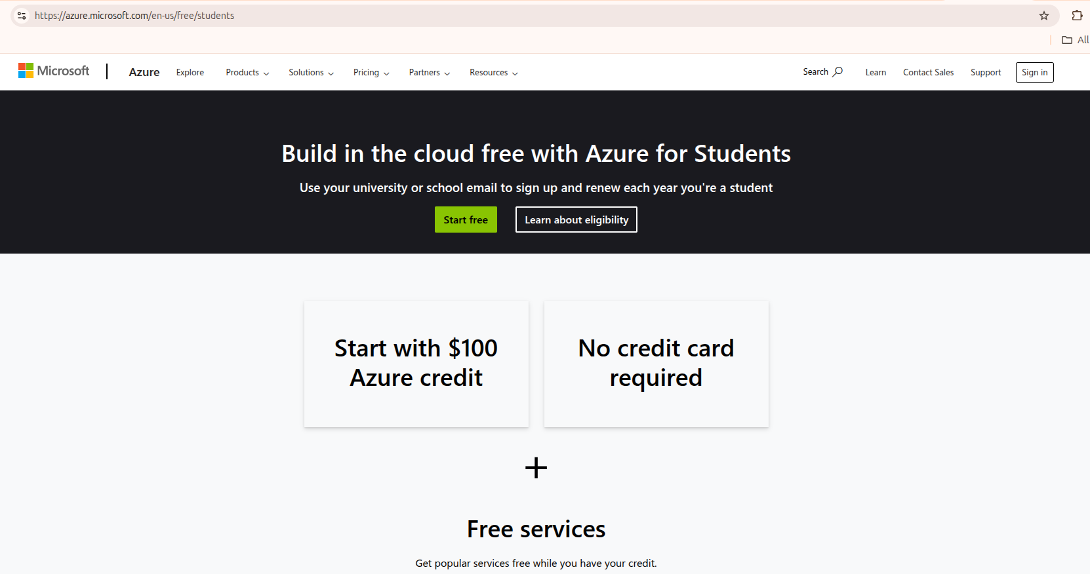

* Click on **Start free**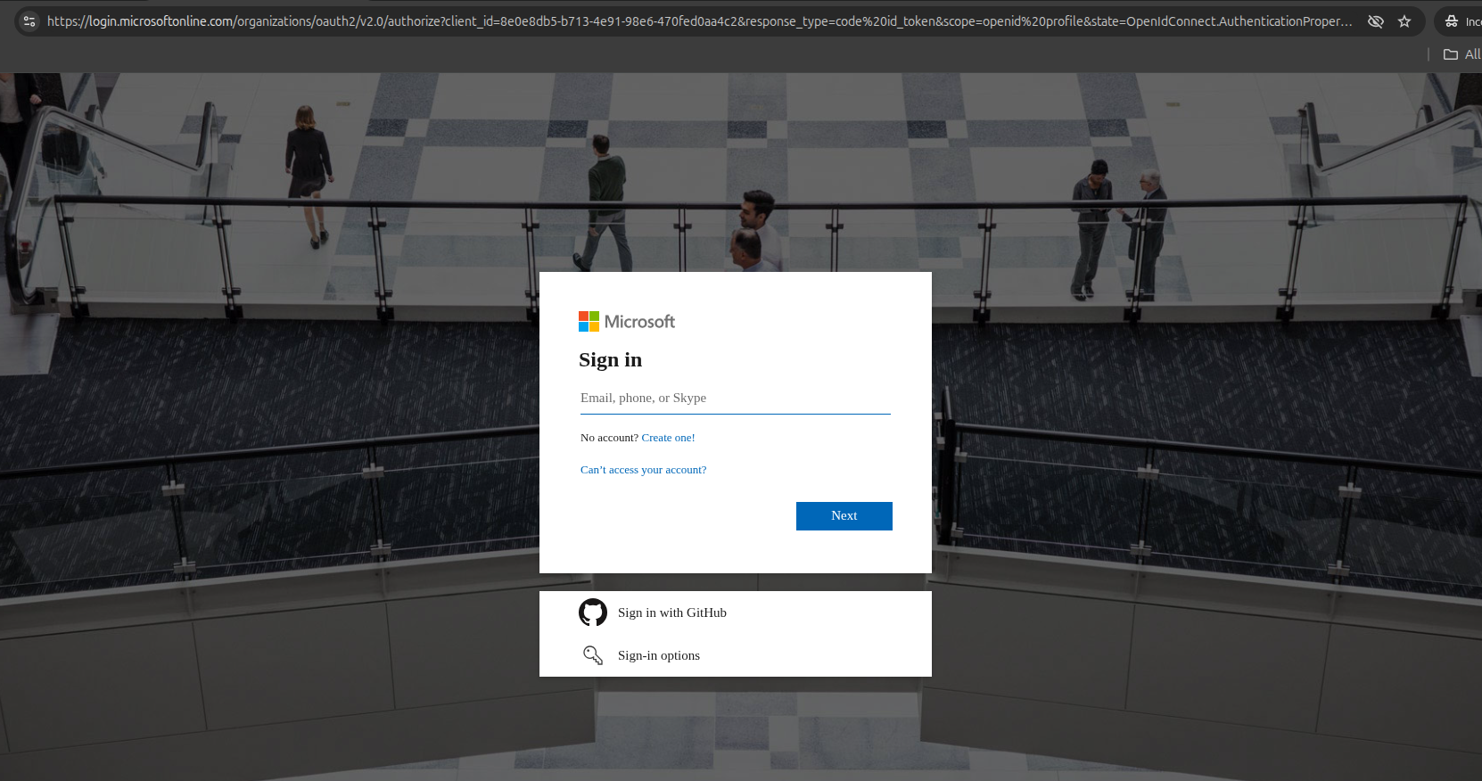
* Enter your personal email id for the registration. (Gmail/Outlook/Yahoo..etc email account)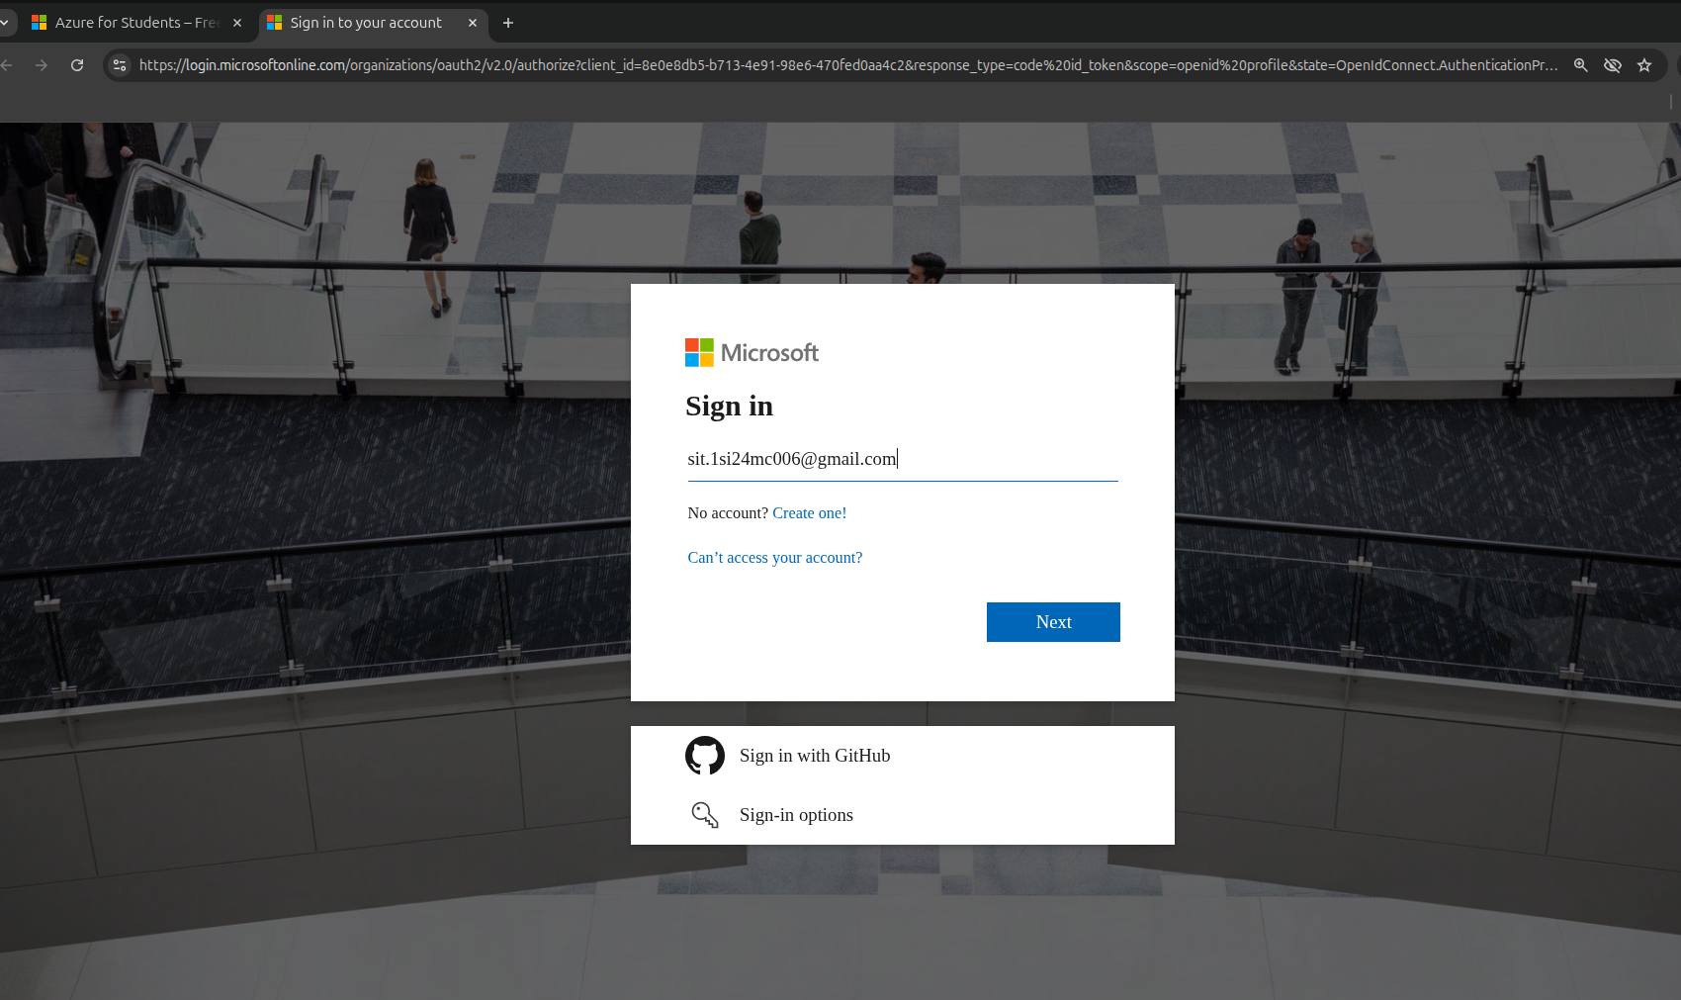
* May prompt the error with your personal id then click on **get new Microsoft account**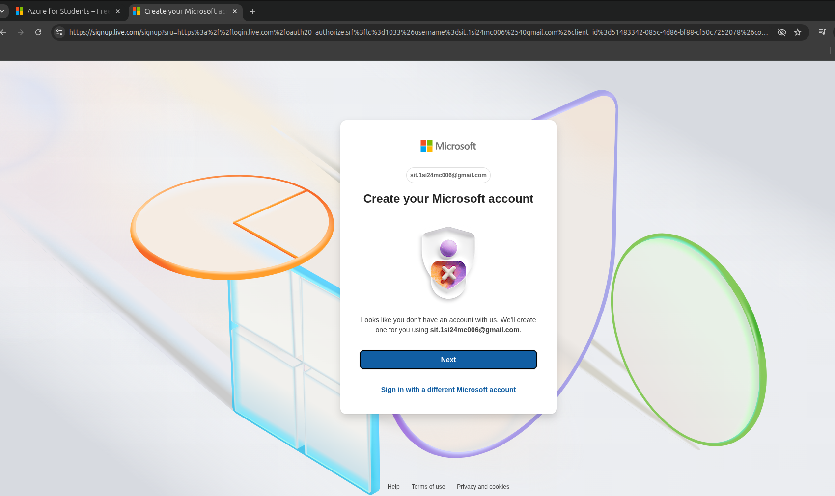
* Click on Next, and it will send OTP on you the personal account mentioned in the previous page.

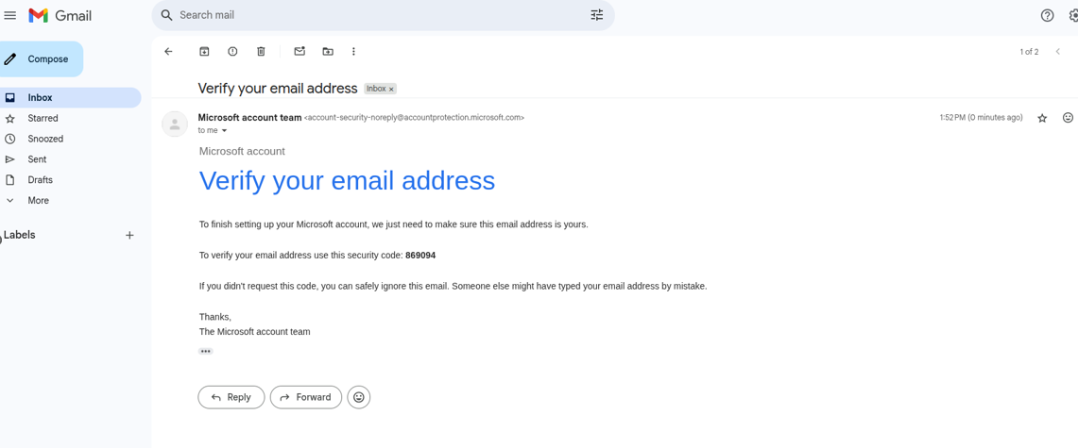

* Enter OTP in the Azure registration process, and click on **Next/Continue**
* Add some personal information to proceed further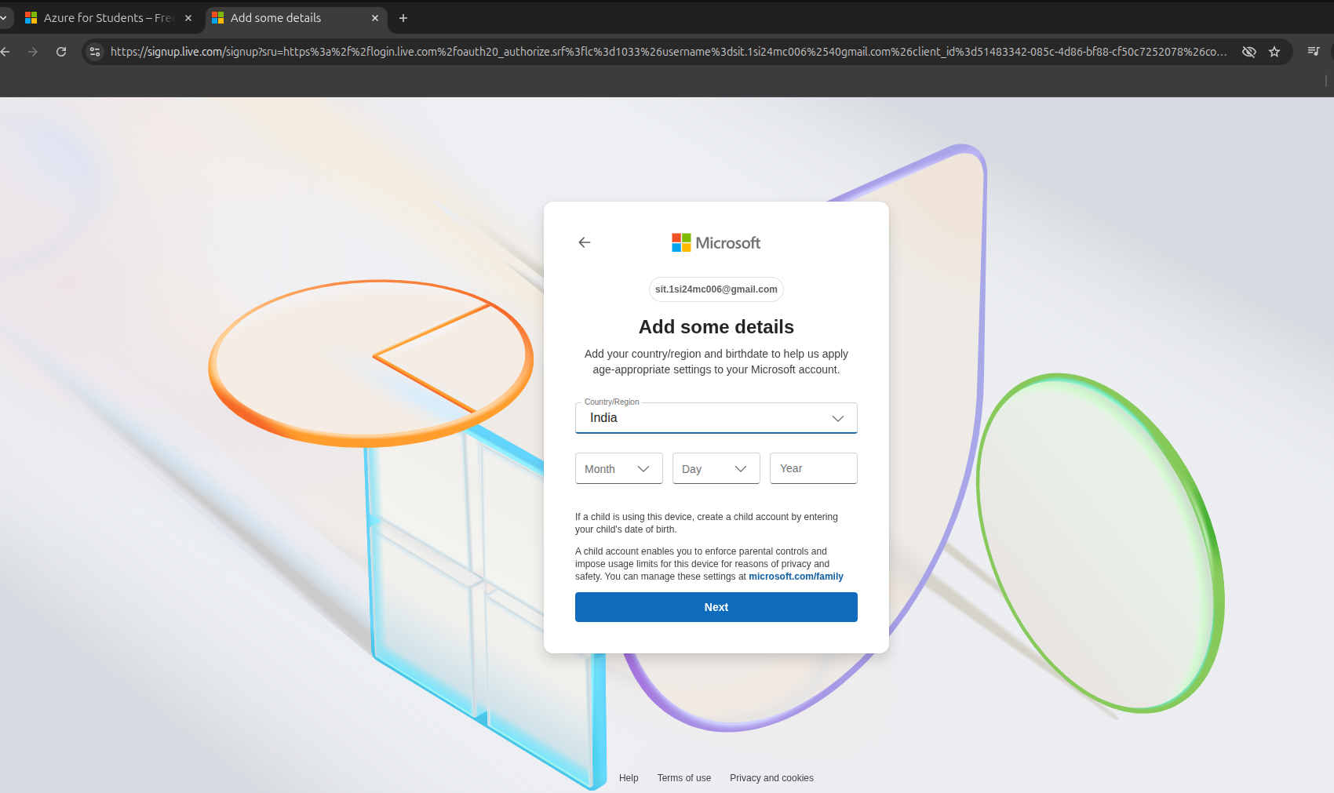, Country, DOB, First, Last Name

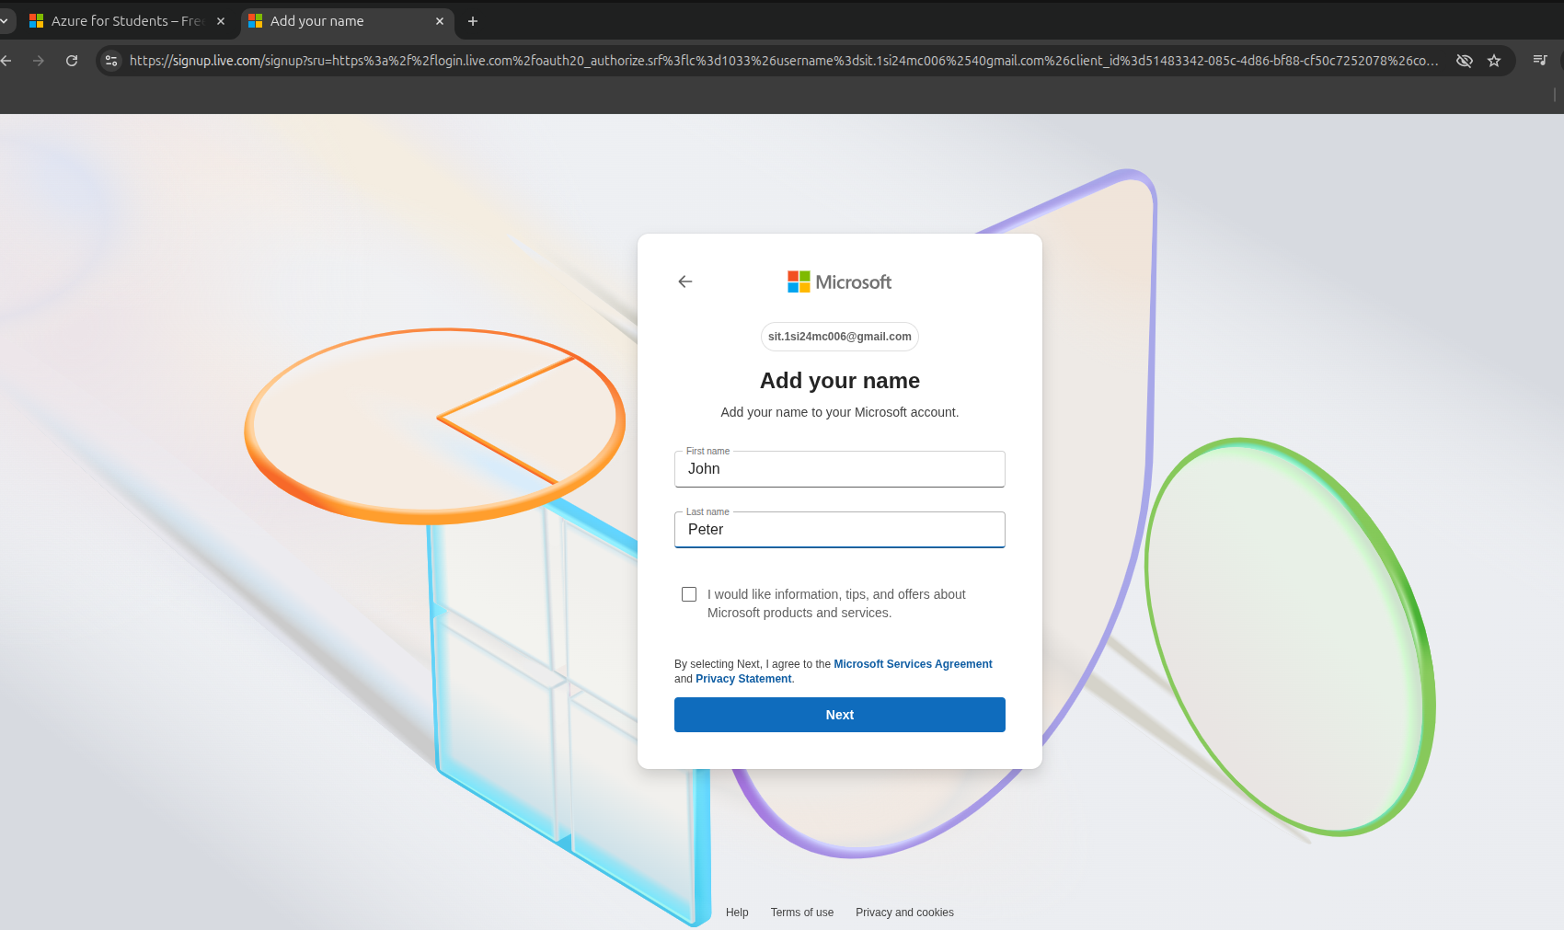

* Click on **Next**

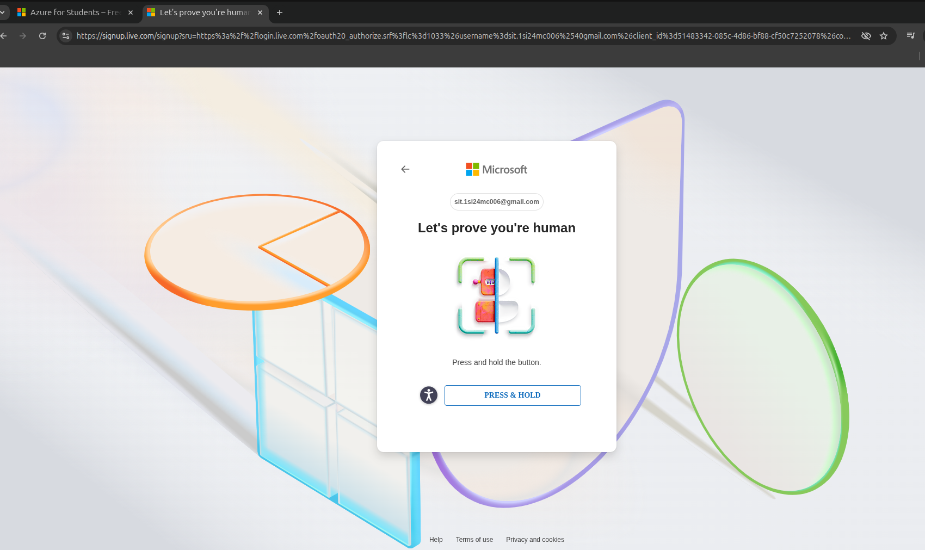

* Click on **PRESS & HOLD,** once verification completed then it takes you to Academic Verification Page
* Enter Academic details about the Students, College, and College Email address like [usn@sit.ac.in](mailto:usn@sit.ac.in)

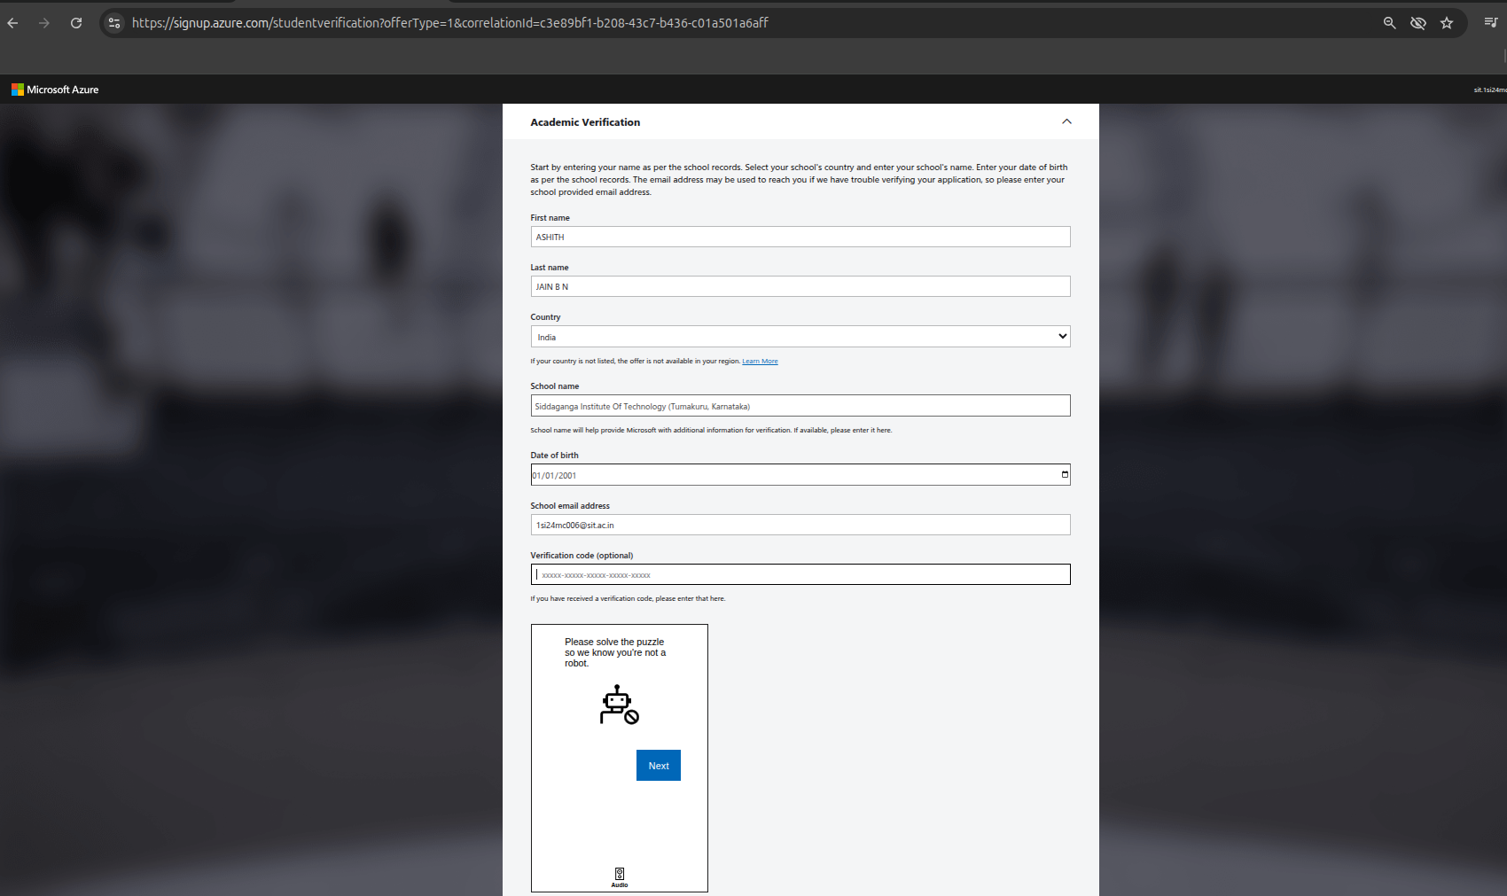

* Enter Student details properly, make sure you are using college email id in this form to get free Azure credit

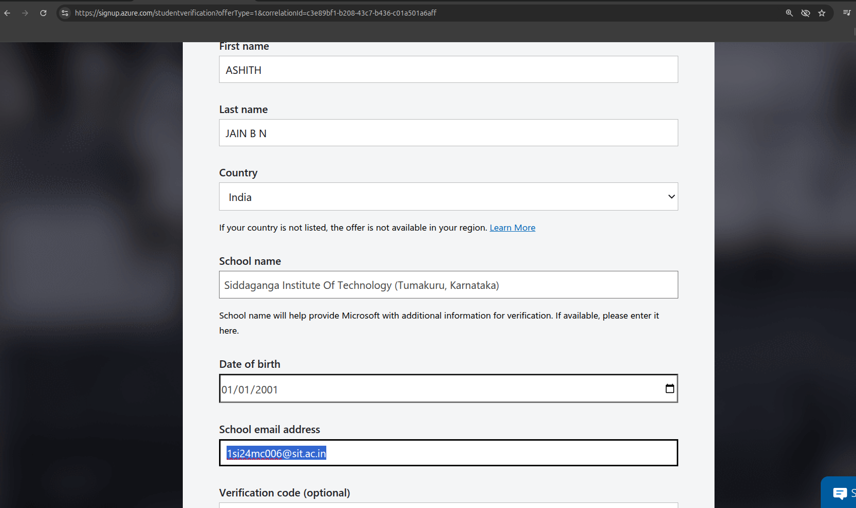

* Scroll down, then verify the **Captcha code**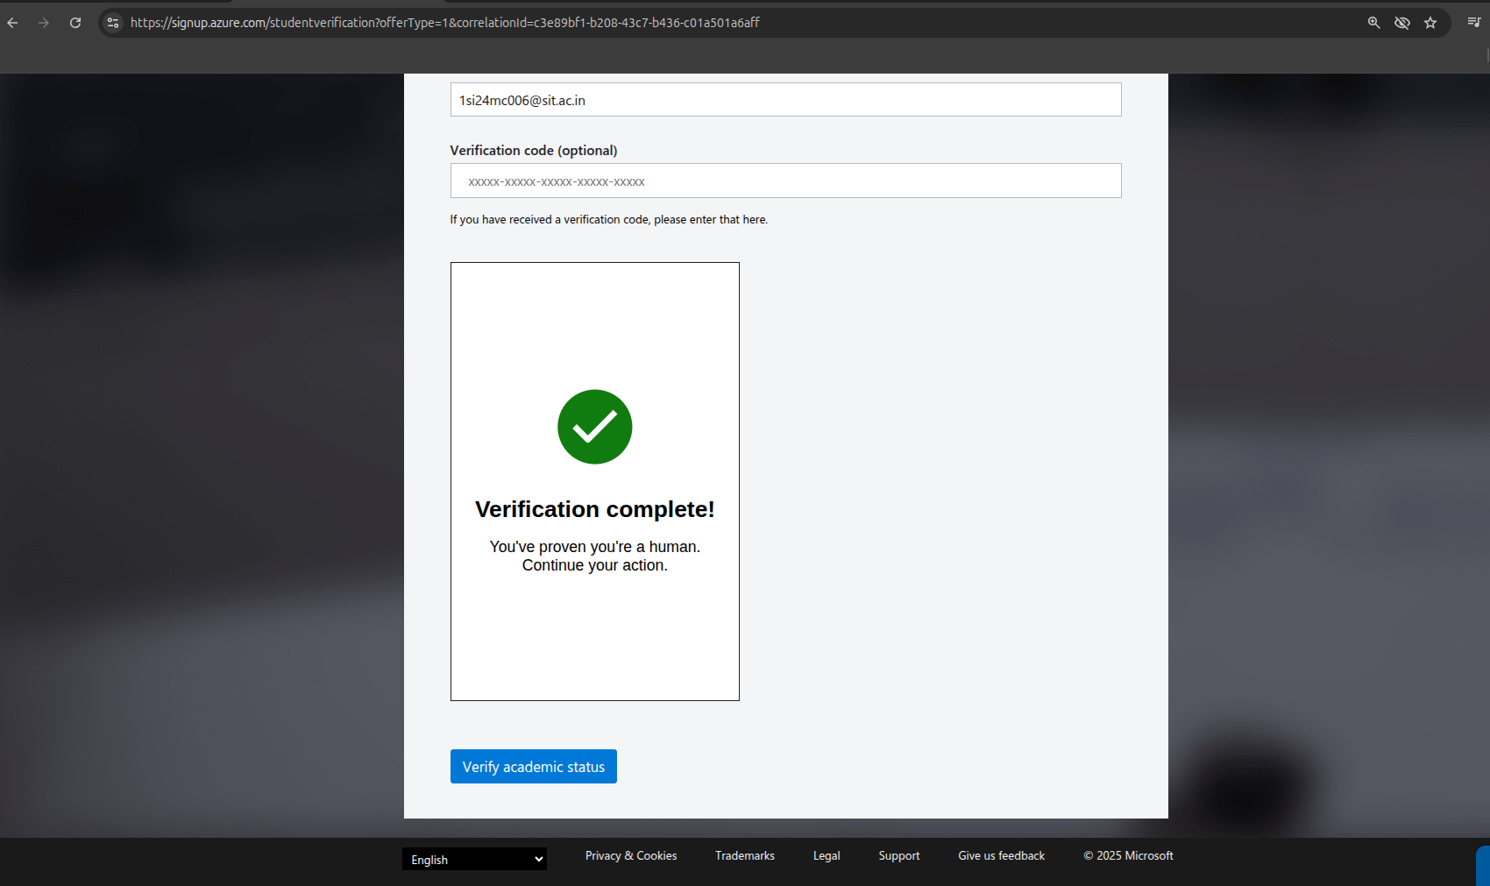
* Click on **Verify academic status**
* Email will be received in your email box of college id **(**[**usnxxx@sit.ac.in**](mailto:usnxxx@sit.ac.in)**)**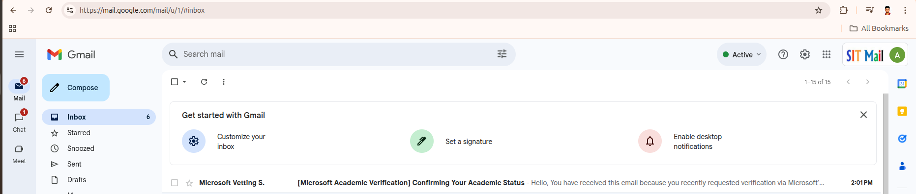
* Verification link will be inside the email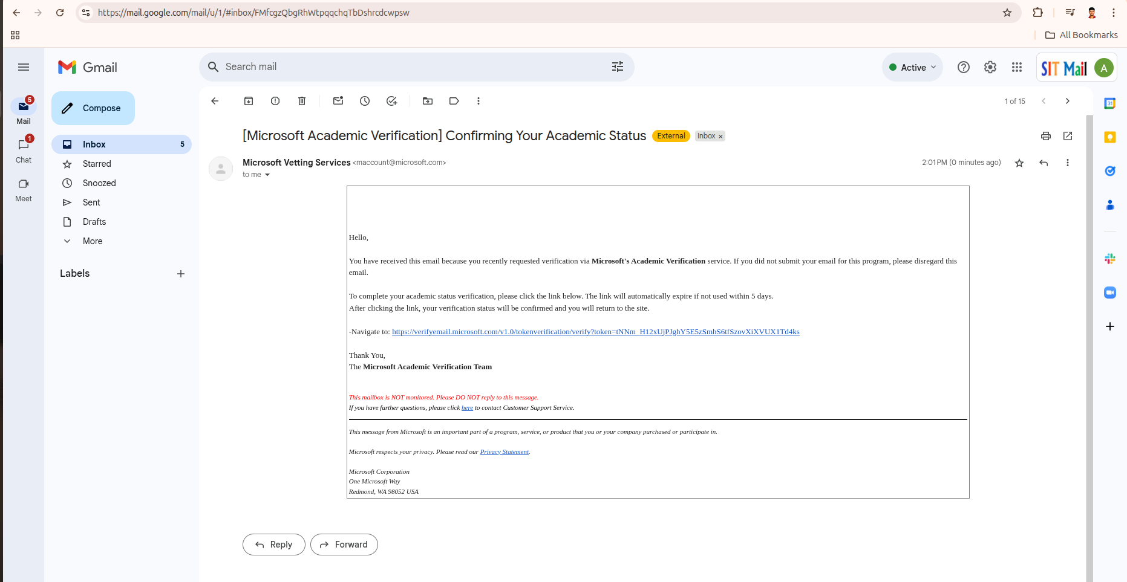

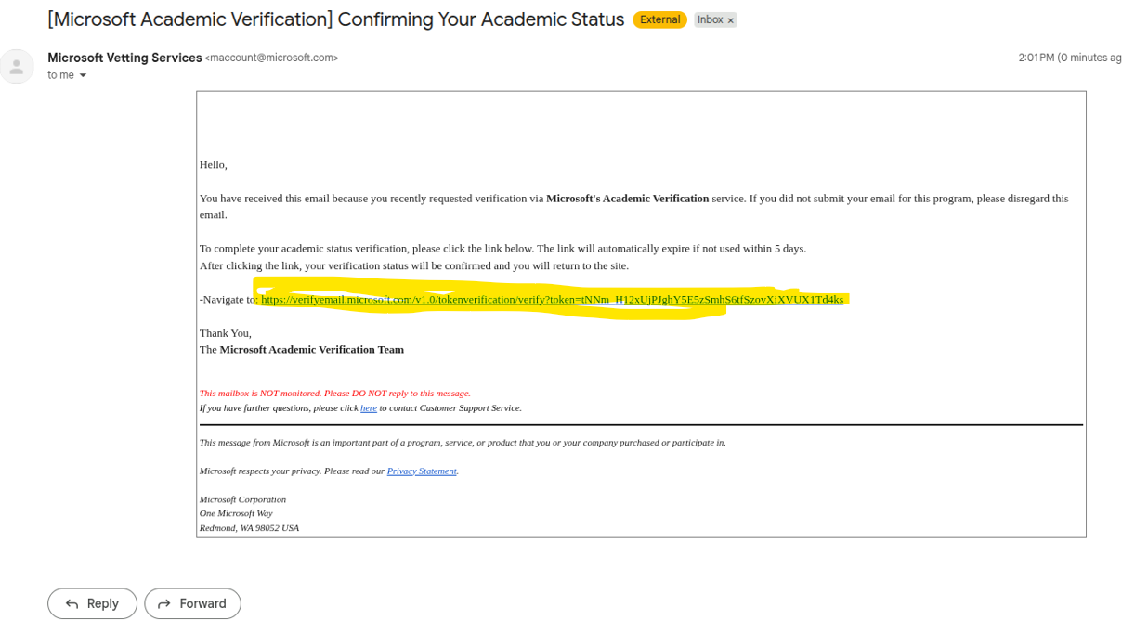

* Click verification link to proceed further on verification.

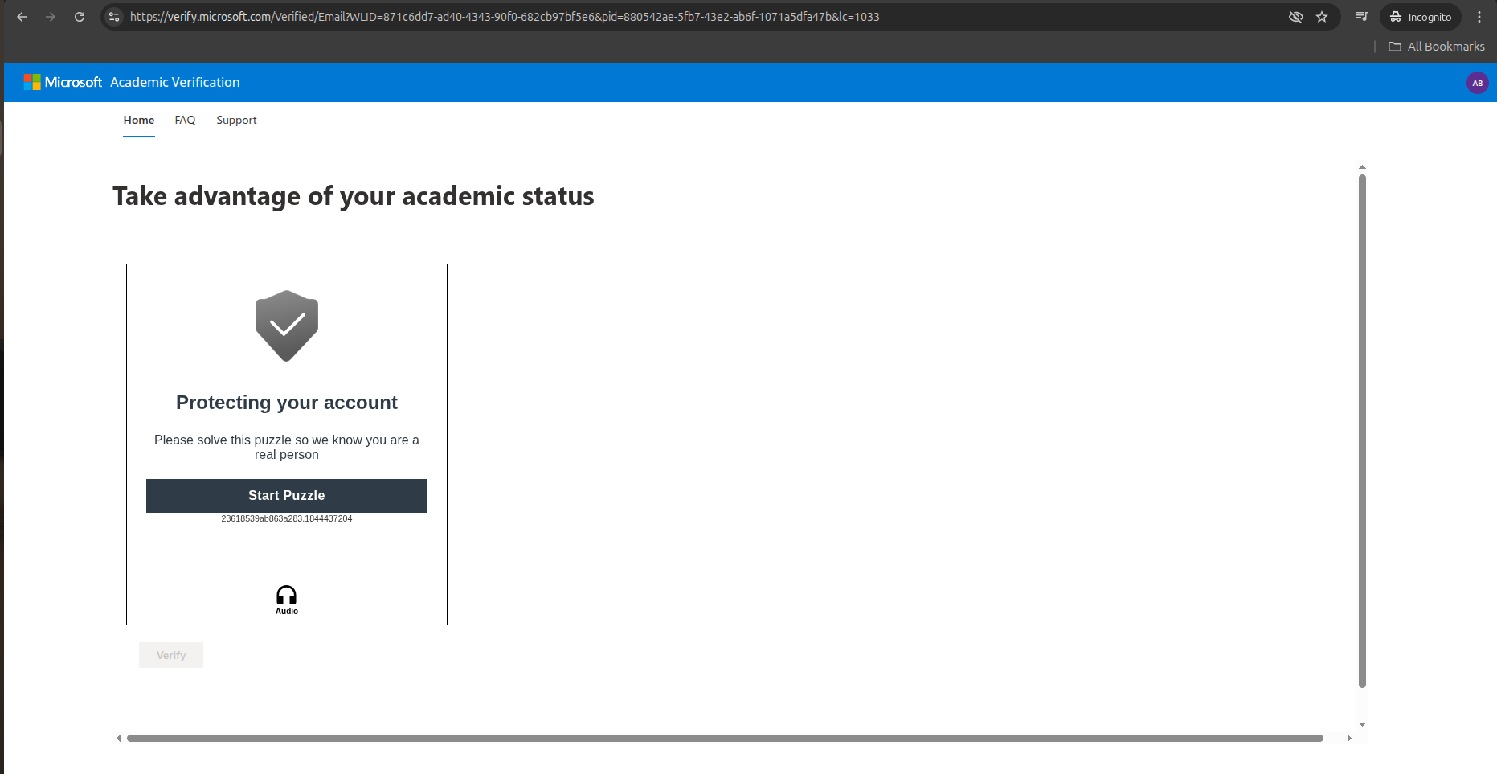

* Solve the Captcha, click on **Verify,** it may prompt you to enter personal details again. Please enter correctly.

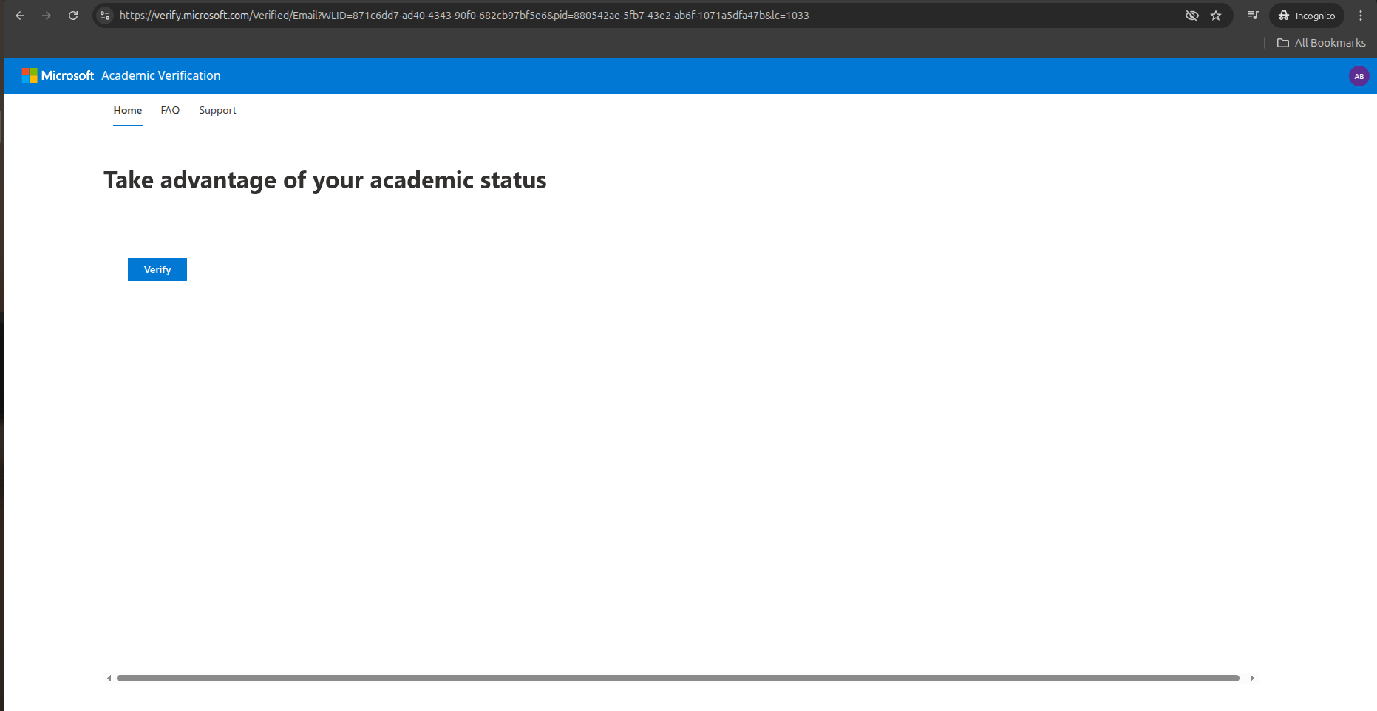

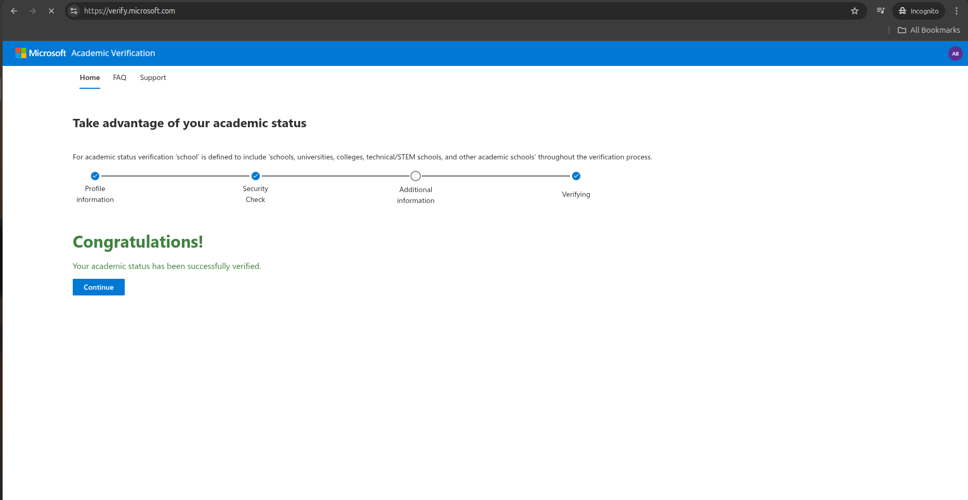

* Click on **Continue**
* Enter Personal details for Azure Portal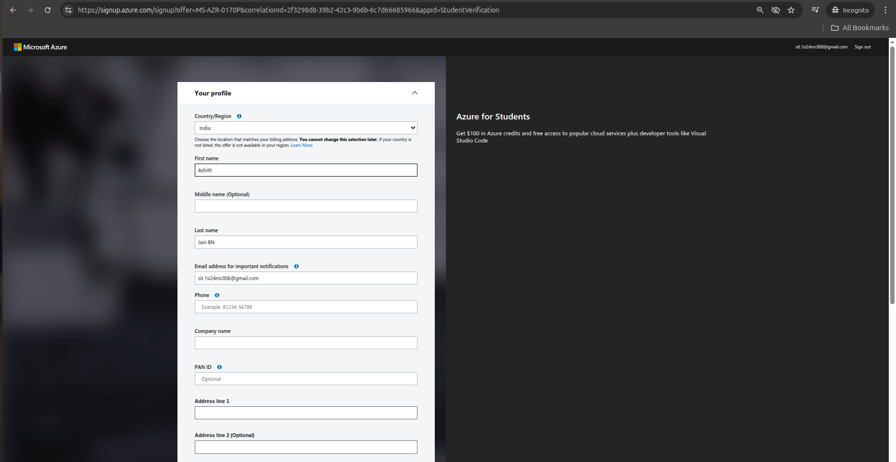

Once the process is complete, you’ll be redirected to the Azure Home Page. Please note that this account is created for educational purposes only and comes with $100 in credits.

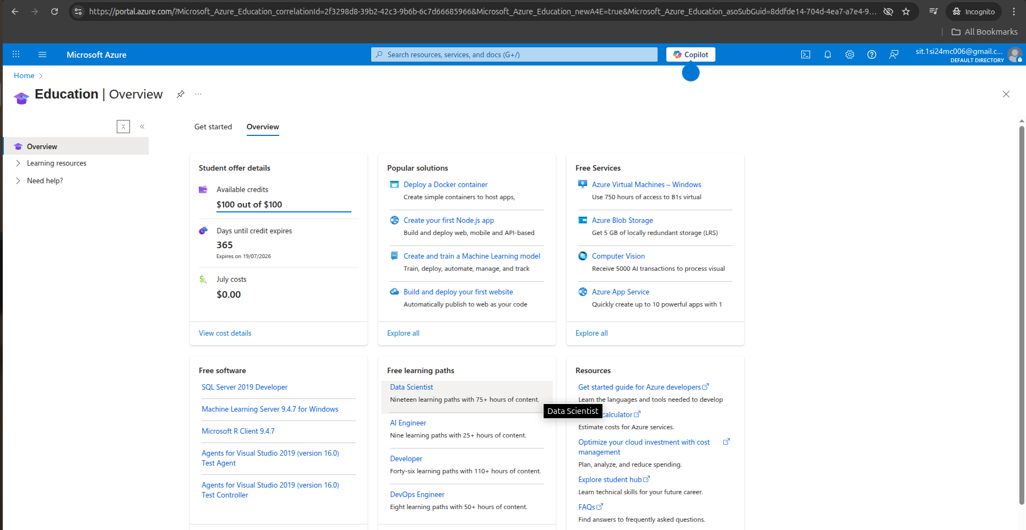

You will also receive a welcome email in your personal account confirming the activation.

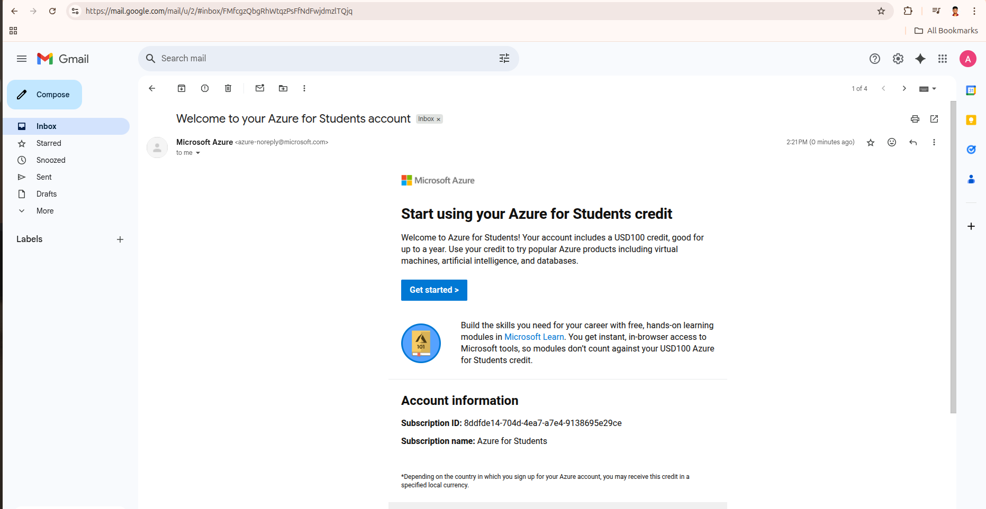

Congratulations! You have been successfully onboarded to the Azure Student Program for learning Azure cloud services.